

# Drawing a Medication or Vitamins from an Ampule

***Follow these steps to draw up medications or vitamins.***

Supplies: medication ampule, syringe with 2 needles (1 needle with a filter and 1 needle without a filter), 2 alcohol pads, and a sharps container

  drawing of a ampoule with label

 

1. Check your patient information and orders. Check your medication label. Make sure your medication label matches your orders. Make sure your medication label includes your name and has the right dose and medication name, and that it has not expired. Make sure there are no particles in the solution.
2. A person wiping down a table

    Follow your orders about how to store your medication.
3. Clean your work area with a cleaning solution and a clean paper towel. Throw the paper towel away.
4. 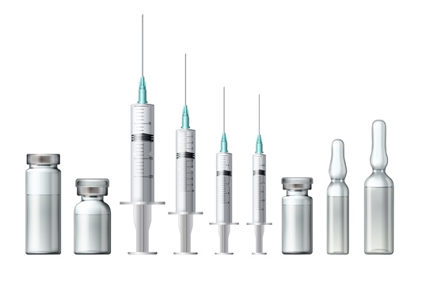**A person washing their hands under a running water faucet
    Wash your hands** for 20 seconds with soap and water. Sing or hum the “Happy Birthday” song twice. Dry your hands with a paper towel or a clean hand towel. Alcohol-based hand sanitizer is an alternative. If you choose to use hand sanitizer, use a dime-sized amount on your hands and rub your hands together until dry. Do not wipe, wave, or blow on your hands to dry them faster.
5. Gather your supplies. Gather your medication ampule, your syringe, your nonfiltered needle, a filtered needle, and two alcohol pads.
6. Draw up your medication.

* Tap the top of the ampule to shake the medication to the bottom of the ampule.
* Scrub the top of the ampule with the alcohol pad for 15 seconds.
* Wrap a new alcohol pad around the top of the ampule. Snap off the top of the ampule with your finger and thumb. Snap it away from you. Throw the top away in the sharps container.
* Place the ampule upright on your clean surface. 
* Attach the filter needle to the syringe. Twist clockwise. Take the cover off.
  + DO NOT TOUCH THE NEEDLE OR SYRINGE TIP! If you do, or if it touches a surface, throw the syringe away and use a new one.
* Place the cover on your clean surface. Do not touch the inside.
* Insert the filtered needle into the opening of the ampule. Draw back on the plunger the amount of medication ordered.
* Remove the syringe from the ampule.
* Remove air from the syringe. Hold the syringe with the needle pointing straight up. Tap gently on the syringe and remove any bubbles. Push the plunger until the air is removed.
* Place the clear cover back on the filtered needle using the scoop method. Twist counterclockwise to remove the filtered needle from the syringe.
* Place a new non-filtered needle on the end of the syringe. Turn clockwise.

1. Follow your orders about how to inject the medication.
2. **WASH HANDS.**
3. **A person washing their hands under a running water faucet
    **If you have been told to add your vitamins to intravenous fluids, find the rubber tip on the IV bag.
4. **WASH HANDS.**
5. Scrub the rubber tip of the IV bag for 15 seconds. Do not drop the rubber tip.
6. Remove the cover of the needle on the syringe. Insert the needle into the rubber tip. Inject all the vitamins into the bag. Remove the entire syringe and throw it into the sharps container.
7. **WASH HANDS.**

If you have been told to add your vitamins to parenteral nutrition (PN) [also called total parenteral nutrition (TPN) or central parenteral nutrition (CPN)], please follow your nurses’ instructions.